GDD
for
Digital Elevator PO4_DGELV

Version 1.2 proposed
Prepared by /
- Ahmed Refaat
- Donia Mohamed
- Marcelle Samir

Jan 27, 2020
Document Status
Version | Document Status | Author | Date
V_1.2 | Proposed | Donia Mohamed  Ahmed Refaat  Marcelle Samir | Feb 27, 2020

Revision History
Name | Version | Author | Date | Change Description | Document Status
GDD_DIGITAL_  ELEVATOR | V_1.0 | Donia Mohamed | Jan 26, 2020 | Initial creation of the GDD Document by adding  1)Naming convention  2)Document status  3)Revision history  4)table of signals  5)context diagram | Draft
GDD_DIGITAL_  ELEVATOR | V_1.1 | Ahmed Refaat | Jan 26, 2020 | Adding the static architecture ( layered architecture) | Draft
GDD_DIGITAL_  ELEVATOR | V_1.2 | Marcelle Samir | Feb 27, 2020 | Adding the static architecture ( components APIs) | Proposed

Reference Table
Ref. Document | Version | Document Status
SRS_DIGITAL_ELEVATOR | V_1.4 | Proposed
HSI_DIGITAL_ELEVATOR | V_1.5 | Released

Table of Contents
Revision History iii
Reference Table iv
1. Introduction 1
1.1 Purpose 1
1.2 Project Scope 1
2. Table of Signals 2
3. Context Diagram 1

Introduction

Purpose
This project aims at developing a Digital Elevator with lock system to be more secure and have specific functionalities.

The purpose of this document is to present a detailed description of the Digital Elevator System. It will explain the purpose, scope and features of the system, the interfaces of the system, what the system will do, the constraints under which it must operate.

Project Scope
This software system will be an Embedded System for a digital elevator. This system will be designed to secure the usage of the elevator and handle the movement of it. By having a limited number of resigned users with unique ID and entered password, we can secure the usage of the elevator. Using some developed buttons, the users can easily control the movement of the elevator.

Table of Signals

Variable | Type | Initial Value | Range of Values
No_Current_Users | Non-Constant | 0 | [0 - 9]
Max_User_No | Constant | 10 | 10
Fully_Occup_Flag | Non-Constant | FALSE | [TRUE / FALSE]
Max_UserName_length | Constant | 10 | 10
Max_PinNum_length | Constant | 4 | 4
Max_No_Trials | Constant | 3 | 3
Wrong_Trials_Flag | Non-Constant | 0 | [0-2]
ON_OFF_Flag | Non-Constant | FALSE | [TRUE / FALSE]
Buzzer_State | Non-Constant | ACTIVE | [ACTIVE / DEACTIVE]
ON_OFF_L_PRESS | Non-Constant | FALSE | [TRUE / FALSE]

Context Diagram
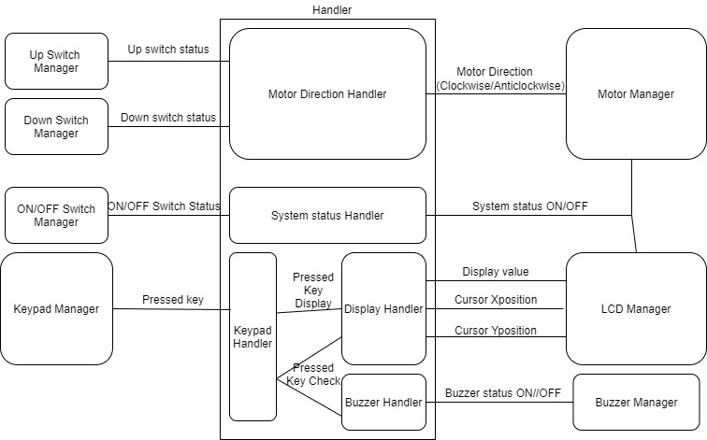

Static Architecture

- Layered architecture

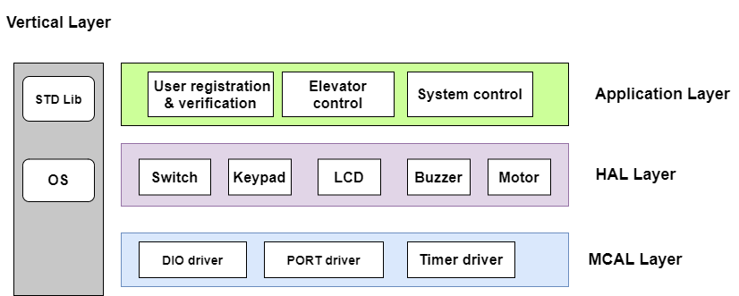

- Component APIs
Req_DIGELV_GDD_01_V1.0

Component Name | DIO_Driver
API Name | Error_Status DIO_SetPinValue(u32 Copy_u32Port, u32 Copy_u32Pin, u32 Copy_u32Value);
Return type | It’s u8 Error_Status, it returns E_OK or E_NO
  E_OK | 0
  E_NOK | 1
Parameters type | u32 Copy_u32Port  u32 Copy_u32Pin  u32 Copy_u32Mode
  PORTA | *((u8*)0x3B)
  PORTB | *((u8*)0x38)
  PORTC | *((u8*)0x35)
  PORTD | *((u8*)0x32)
  PIN0 | 0
  PIN1 | 1
  PIN2 | 2
  PIN3 | 3
  PIN4 | 4
  PIN5 | 5
  PIN6 | 6
  PIN7 | 7
  LOW | 0
  HIGH | 1
  PULLUP | 1
Description | The functionality of this API to select its value if it’s HIGH or LOW or PULLUP (in case of the pin is INPUT) of a PIN by sending the pin number and port number as arguments

Req_DIGELV_GDD_02_V1.0

Component Name | DIO_Driver
API Name | Error_Status DIO_SetPinDIR(u32 Copy_u32Port, u32 Copy_u32Pin, u32 Copy_u32Mode);
Return type | It’s u8 Error_Status, it returns E_OK or E_NO
  E_OK | 0
  E_NOK | 1
Parameters type | u32 Copy_u32Port  u32 Copy_u32Pin  u32 Copy_u32Mode
  PORTA | *((u8*)0x3B)
  PORTB | *((u8*)0x38)
  PORTC | *((u8*)0x35)
  PORTD | *((u8*)0x32)
  PIN0 | 0
  PIN1 | 1
  PIN2 | 2
  PIN3 | 3
  PIN4 | 4
  PIN5 | 5
  PIN6 | 6
  PIN7 | 7
  INPUT_PIN | 0
  OUTPUT_PIN | 1
Description | The functionality of this API to select the Mode if it’s INPUT or OUTPUT of a PIN by sending the pin number and port number as arguments

Req_DIGELV_GDD_03_V1.0

Component Name | DIO_Driver
API Name | Error_Status DIO_GetPinValue(u32 Copy_u32Port, u32 Copy_u32Pin, u32 *Copy_u32Value);
Return type | It’s u8 Error_Status, it returns E_OK or E_NO
  E_OK | 0
  E_NOK | 1
Parameters type | u32 Copy_u32Port  u32 Copy_u32Pin  u32 *Copy_u32Mode  it’s a pointer where the read value will be written in
  PORTA | *((u8*)0x3B)
  PORTB | *((u8*)0x38)
  PORTC | *((u8*)0x35)
  PORTD | *((u8*)0x32)
  PIN0 | 0
  PIN1 | 1
  PIN2 | 2
  PIN3 | 3
  PIN4 | 4
  PIN5 | 5
  PIN6 | 6
  PIN7 | 7
Description | The functionality of this API to read the of a PIN by sending the pin number and port number as arguments and receiving the read value in a pointer.

Req_DIGELV_GDD_04_V1.0
Component Name | PORT_Driver
API Name | Error_Status PortIntitialize(void);
Return type | It’s u8 Error_Status, it returns E_OK or E_NO
  E_OK | 0
  E_NOK | 1
Parameters type | It doesn’t take any parameters
  INPUT | 0
  OUTPUT | 1
  PORTA_PIN0_DIR | OUTPUT | PORTC_PIN0_DIR | OUTPUT
  PORTA_PIN1_DIR | OUTPUT | PORTC_PIN1_DIR | OUTPUT
  PORTA_PIN2_DIR | OUTPUT | PORTC_PIN2_DIR | OUTPUT
  PORTA_PIN3_DIR | OUTPUT | PORTC_PIN3_DIR | OUTPUT
  PORTA_PIN4_DIR | OUTPUT | PORTC_PIN4_DIR | OUTPUT
  PORTA_PIN5_DIR | INPUT | PORTC_PIN5_DIR | INPUT
  PORTA_PIN6_DIR | INPUT | PORTC_PIN6_DIR | INPUT
  PORTA_PIN7_DIR | OUTPUT | PORTC_PIN7_DIR | OUTPUT
  PORTB_PIN0_DIR | OUTPUT | PORTD_PIN0_DIR | OUTPUT
  PORTB_PIN1_DIR | INPUT | PORTD_PIN1_DIR | INPUT
  PORTB_PIN2_DIR | INPUT | PORTD_PIN2_DIR | INPUT
  PORTB_PIN3_DIR | OUTPUT | PORTD_PIN3_DIR | OUTPUT
  PORTB_PIN4_DIR | OUTPUT | PORTD_PIN4_DIR | OUTPUT
  PORTB_PIN5_DIR | OUTPUT | PORTD_PIN5_DIR | OUTPUT
  PORTB_PIN6_DIR | INPUT | PORTD_PIN6_DIR | INPUT
  PORTB_PIN7_DIR | INPUT | PORTD_PIN7_DIR | INPUT
Description | The functionality of this API to make it easier to set all pins at with one function call, by predefined values to set each pin INPUT or OUTPUT pin

Req_DIGELV_GDD_05_V1.0

Component Name | Switch_Driver
API Name | Error_Status GetSwitchState(u8 *Copy_u8SwitchValue);
Return type | It’s u8 Error_Status, it returns E_OK or E_NO
  E_OK | 0
  E_NOK | 1
Parameters type | u8 *Copy_u8SwitchValue  it’s a pointer where the read value will be written in  and there are predefined configurations
  SW_PIN | Pin number ( 0 or 1 or 2 or 3 or 4 or 5 or 6 or 7)
  SW_PORT | Selected port (PORTA or PORTB or PORTC or PORTD)
  RELEASE_State | PULLUP or PULLDOWN
Description | The functionality of this API to read the switch value by receiving the read value in a pointer.

Req_DIGELV_GDD_06_V1.0

Component Name | LCD_Driver
API Name | Error_Status CLCD_voidInitialize(void);
Return type | It’s u8 Error_Status, it returns E_OK or E_NO
  E_OK | 0
  E_NOK | 1
Parameters type | It doesn’t take any parameters
Description | The functionality of this API to make the hardware ready by applying standard sequence on it.

Req_DIGELV_GDD_07_V1.0

Component Name | LCD_Driver
API Name | Error_Status CLCD_voidGoToXVPos(u8 Copy_u8XPos, u8 Copy_u8YPos);
Return type | It’s u8 Error_Status, it returns E_OK or E_NO
  E_OK | 0
  E_NOK | 1
Parameters type | u8 Copy_u8XPos  this parameter takes the number of x position  u8 Copy_u8YPos  this parameter takes the number of y position, it has 2 options ( CLCD_U8_LINE_TWO or CLCD_U8_LINE_ONE)
Description | The functionality of this API to move the cursor to the desired position

